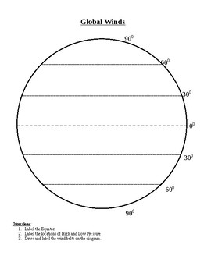
Label:
Lines of latitude - 0, 30, 60, 90
Global Winds and the direction of the winds :
Trade Winds
Equatorial Doldrums
Westerlies
Easterlies

Complete the information
 | Symbol | Air Mass | Weather During | Weather After
Cold  Front |  | 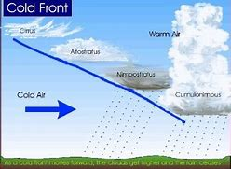
Warm  Front |  | 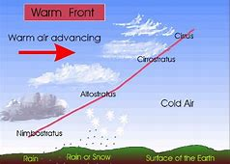
Occluded Front |  | 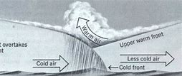
Stationary  Front |  | 